COVID-19 Return to Work Risk Assessment

Following the completion of the return to work checklist, you must apply the findings to assess the risk to anyone who make enter your premises or workplace. The Risk assessment must be completed to ensure the risk of contracting COVID-19 has been reduced to the lowest level reasonably practicable. Once completed, you must communicate the significant findings of the risk assessment to anyone affected.
Current Government guidance suggests you should consider publishing the results of your risk assessment on your website (and would expect all employers with over 50 workers to do so).
You should display this completed notice in your workplace to show you have followed current Government guidance
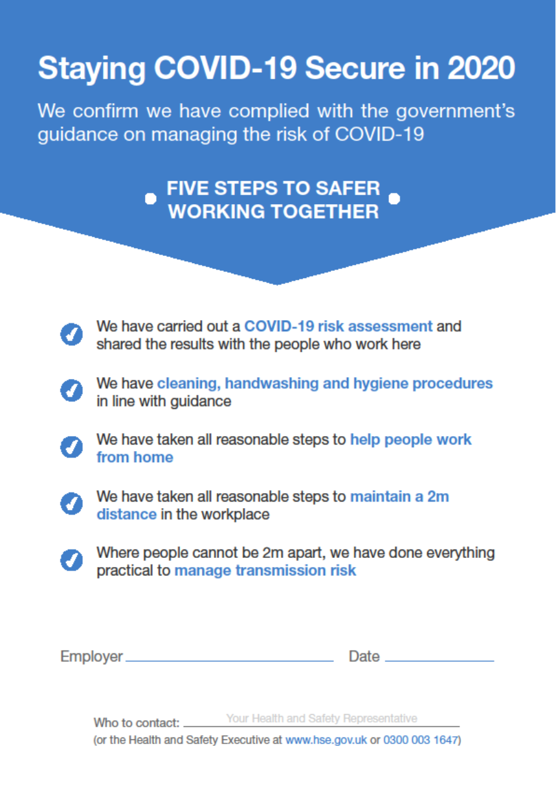

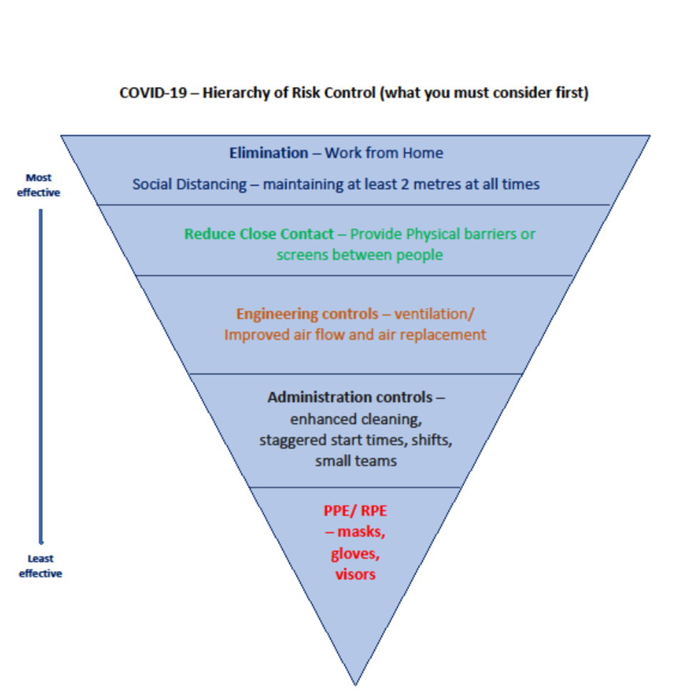

COVID-19 Risk Assessment Template
Completed By: |  | Responsible Person:
Workplace Location: |  | Date Completed:

Hazard | Who is at Risk | Current Control Measures | Further Action Required Y/N | Further Action | Responsibility | Timescale | Date Completed
- Poor Planning  - No covid-19 plan in place by Senior Managers  - Vulnerable groups not identified  - Not allowing staff to continue to work from home  - No return to working consultation, briefings or training planned  - No support provided for staff who may be anxious or experience stress when returning to work. | Staff  Visitors  Contractors
- No Additional Cleaning and/or Hygiene Preparation
- No additional cleaning schedule established
- No additional supplies of soap, disinfectant and hand sanitiser ordered and replenished
- No posters and notices displayed warning of covid-19 hazards
- No additional bins and cleaning procedures planned.

- No Additional Control of Entry/ Exit Points of the Building
- No planned staggered start/ finish times
- No additional entry/ exit points identified for peak times
- No consideration of one-way systems
- Door entry systems and touch keypads still being used
- Deliveries being brought into the building with no control.

- Facilities and Utilities not Checked Before the Building is Re-occupied, including:
- Legionella;
- Fire safety;
- Gas supplies and appliances;
- Electrical supplies and equipment;
- Lifting equipment;
- Work equipment;
- Ventilation and air conditioning;
- Security Systems.

- No Segregation of Social Distancing Measures in Place
- Close contact work being completed
- Physical/skin contact
- Passenger lifts being used
- No physical barriers provided
- Workers with 2 metres when carrying out tasks
- Face to face working being completed
- Poor ventilation in working areas
- Teams members are swapped regularly
- More than 15 minutes close contact between workers
- Poor monitoring and managing of close contact activities.

- Lack of PPE Supplies and Control of Use
- No PPE needs assessment completed
- PPE being used before other safer controls (distancing/ barriers etc.)
- No PPE training/ fit testing or instruction provided
- Disposable PPE used too often and not disposed of
- No cleaning or storage regime for reusable PPE.

- Poor Control of Toilet and Welfare and Facilities
- No additional time allocated for workers to wash hands more regularly
- No hand sanitiser provided at various location (minimum 60% alcohol)
- Soap and hand wash not restocked regularly
- No enhanced disinfecting schedules for facilities
- No signage provided to remind workers to wash hands before and after using facilities
- Poor or little ventilation in welfare/ toilet areas
- Enclosed bins not provided or emptied daily
- Towel sharing - no disposable hand towels provided
- Hand dryers spraying excess water particles in the air available to use

- Poor Control of Canteen and Rest Facilities
- Staff share facilities and no enhanced cleaning
- Seating distances with 2 metres
- No segregation of workers or staggered break times
- No hand sanitiser or soap provided
- Tables and chairs not cleaned between use
- Canteen staff working within 2 metres of each other
- No monitoring or inspections completed in the area.

- Poor Control of Shower and Changing Facilities
- No control or separation of workers using the facilities
- No staggered start times established to avoid overcrowding
- No enhanced cleaning schedules established
- No individual clothing storage facilities provided
- No additional enclosed rubbish bins provided or emptied daily.

- No Enhanced Workplace Cleaning Schedules in Place
- No additional COSHH assessments completed for new/ more frequent cleaning schedules or substances
- No training provided to cleaners/contract cleaners
- No consideration to change cleaning methods (avoid splashing etc.)
- No disinfectant or diluted bleach supplies available or on order
- No additional PPE provided for cleaners
- No additional disposable towels, mop heads, cloths etc. provided.

- No Additional Fire Aiders or PPE Available
- First aid needs assessment not reviewed
- Lack of trained first aiders available due to new work patterns
- No specific COVID-19 related PPE or training provided to First Aiders
- No procedures established to dispose of contaminated waste
- No plans established if emergency services are not immediately available due to the pandemic
- No enhanced cleaning procedure established after First Aid treatment in the workplace.

- Vehicle Use and Travelling to Work
- Workers sharing vehicles to get to work
- Workers using public transport to get to work
- No additional parking spaces provided
- No training or instruction provided to employees relating to commuting
- Company vehicles shared by workers
- No cleaning or sanitising products provided in company vehicles
- No plans established to separate workers who have to share vehicles
- No additional cleaning schedules established for vehicle interiors and touch points
- No of Control of Deliveries, Contractors or Visiting Other Premises
- Deliveries or visiting contactors allowed to enter the building
- Deliveries entering the building without being sanitised/ disinfected
- No plan or instructions given to maintenance contractors prior to attending the premises
- No plan established if workers visit other work locations or client premises.

Disclosure of Information, Use of Personal Data & Confidentiality
Information provided to us by you will remain confidential and be used for the purpose of providing the agreed service to you, or to others where we are required to fulfil a regulatory or legal obligation and as set out in our Privacy and Fair Processing Policy.
Where appropriate, information which passes between both parties of this agreement could be deemed as a material fact by your insurers and should be disclosed to them. In such circumstances where Thomas Carroll (Brokers) Limited act as your appointed insurance broker this information will be passed to them unless you specifically instruct us, in writing, not to do so and confirm that you fully understand the implications of your decision. In all other circumstances, you are advised to disclose such information to your insurance service provider. Failure to do so could invalidate your insurance cover. Any written instruction provided to Thomas Carroll Management Services not to disclose information to Thomas Carroll (Brokers) Limited must be received by Thomas Carroll Management Services within 5 working days following the delivery of each part of the agreed service, or immediately in the case of an incident that could result in an insurance claim.
Any accident or incident notified to Thomas Carroll Management Services or added to the Health and Safety Management Software does not constitute the formal notification of a potential claim to Thomas, Carroll (Brokers) Ltd. In such circumstances a separate claims notification must be made to the Claims Department of Thomas, Carroll (Brokers) Ltd. Any delay in notification to Thomas, Carroll (Brokers) Ltd could be deemed as late notification by insurers and may result in non- payment of the claim.
All advice provided by Thomas Carroll Management Services, as part of the agreed service, should be read in conjunction with your insurance policies to ensure compliance with warranties and conditions.
Any personal information will be used to understand your needs and improve our services. It may be shared with third parties where required to do so for us to provide our services to you, or where we have appointed third parties to manage our business. Where you have agreed, or in circumstances where to do so will be in our mutual interests, we may contact you, or pass on your contact details to other companies within the Thomas, Carroll Group, to provide you with further information about our wider products and services. You can opt out from receiving such communications by contacting us.
In your dealings with us you may provide us with information that may include data that is known as personal data. Where we process personal data, we comply with statutory data processing requirements as set out by the Data Protection Act 2018. The personal data we will collect may include information relating to your name, address, date of birth, health or criminal offences.
The Data Protection Act 2018 provides you with Access Rights that allow you to gain an understanding on the data being processed, who we share it with, for what purpose, why we need to retain it and retention periods, to object to the processing and to place restrictions on the processing, to request copies of your data and to request the deletion of your data. If you require further information on how we process your data or you wish to exercise your rights, please contact us. How we process your personal data is detailed further within our Privacy & Fair Processing Policy, which can be accessed via our website at www.thomascarroll.co.uk or a copy can be provided on request.
Information provided to you by us by way of reports and publications constitutes confidential and proprietary information belonging to us and may only be disclosed and/or used in accordance with permission granted by us. Any other disclosure and/or use is strictly prohibited and we reserve the rights amongst others, to take such action as is necessary to protect our confidential and proprietary information.
Please note that English Law recognises the existence of an implied contract of insurance permitting insurers to inspect certain documents which we hold. Some insurers have slightly wider access than others. You should be aware that the right to inspect does not depend on your prior consent having been given.
Please note that telephone calls with us may be recorded for compliance and training purposes.
Credit Checks/Money Laundering/Proceeds of Crime Act
We and other firms (insurers or credit lenders) involved in arranging your insurance and/or credit, may use public and personal data from a variety of sources including credit reference agencies and other organisations. The information is used to help tailor a price and to help prevent fraud. Any credit reference search will appear on your credit report, whether or not your application proceeds. If you have any questions about this or any other matter, please contact us.
We are obliged to conduct reasonable due diligence to protect us, our clients and insurers against the risk of financial crime. At the start and throughout our relationship, we may require you to provide evidence to assist us in verifying your identity and/or legitimacy of any transactions we conduct on your behalf.
Neither party shall be involved in the offering, promising or giving of any financial or other advantage to any person in breach of any anti-bribery laws (including the Bribery Act 2010).
We are obliged to report evidence or suspicion of financial crime to the relevant authorities at the earliest reasonable opportunity and may be prohibited from disclosing this report to you,
We are not permitted to conduct business with any customer who is subject to sanctions and embargoes. If sanctions or embargoes are in place, then we will not be able to proceed with transactions on your behalf and your insurers may terminate your insurance contract and not pay any claims that have been notified. If you subsequently become subject to sanctions or embargoes, we may have to terminate our relationship and your insurer may invoke its cancellation rights under your policy, as well as being unable to proceed with any claims that have been notified.

